**DAA Programs**

**Fibonacci series using Recursion.**

#include<stdio.h>

int fibonacciSeries(int n){

if(n<=1)

return n;

return fibonacciSeries(n-1)+fibonacciSeries(n-2);

}

int main(){

int n,i;

printf("Enter number of series: ");

scanf("%d",&n);

printf("Fibonacci series:\n");

for(i=0;i<n;i++){

printf("%d ",fibonacciSeries(i));

}

return 0;

}

**Output:**

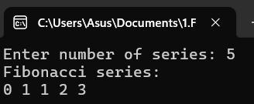

**Armstrong Number.**

#include<stdio.h>

#include<math.h>

int main(){

int n,sum=0,rem,temp;

printf("Enter a number: ");

scanf("%d",&n);

temp=n;

while(n>0){

rem=n%10;

sum=sum+pow(rem,3);

n/=10;

}

if(temp==sum)

printf("%d is an Armstrong number",temp);

else

printf("%d is not an Armstrong number",temp);

return 0;

}

**Output:**

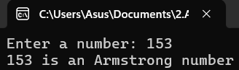

**GCD of two numbers.**

#include<stdio.h>

int main(){

int a,b,rem;

printf("Enter two numbers: ");

scanf("%d %d",&a,&b);

int n1=a;

int n2=b;

while(b!=0){

rem=a%b;

a=b;

b=rem;

}

printf("GCD of %d and %d is %d",n1,n2,a);

}

**Output:**

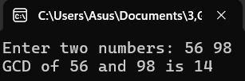

**4. Largest element in an array.**

#include<stdio.h>

int main(){

int n,i;

printf("Enter no of elements: ");

scanf("%d",&n);

int arr[n];

printf("Enter %d elements: ",n);

for(i=0;i<n;i++){

scanf("%d",&arr[i]);

}

int max=arr[0];

for(i=0;i<n;i++){

if(arr[i]>max)

max=arr[i];

}

printf("Largest element: %d",max);

return 0;

}

**Output:**

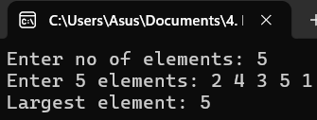

**5. Factorial of a number.**

#include<stdio.h>

int main(){

int n,i,fact=1;

printf("Enter a number: ");

scanf("%d",&n);

for(i=1;i<=n;i++){

fact=fact*i;

}

printf("Factorial of %d is %d",n,fact);

return 0;

}

**Output:**

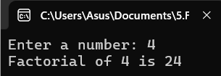

**6. Prime number.**

#include<stdio.h>

int main(){

int n,i,count=0;

printf("Enter a number: ");

scanf("%d",&n);

for(i=1;i<=n;i++){

if(n%i==0)

count++;

}

if(count==2)

printf("%d is a prime number",n);

else

printf("%d is not a prime number",n);

return 0;

}

**Output:**

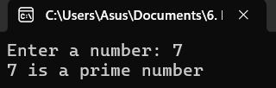

**7. Selection Sort.**

#include<stdio.h>

void selectionSort(int arr[],int n){

int i,j,minIndex,temp;

for(i=0;i<n;i++){

minIndex=i;

for(j=i+1;j<n;j++){

if(arr[j]<arr[minIndex]){

minIndex=j;

}

}

if(minIndex!=i){

temp=arr[i];

arr[i]=arr[minIndex];

arr[minIndex]=temp;

}

}

}

void printArray(int arr[],int n){

int i;

for(i=0;i<n;i++){

printf("%d ",arr[i]);

}

printf("\n");

}

int main(){

int i,n;

printf("Enter size of the array: ");

scanf("%d",&n);

int arr[n];

printf("Enter elements: ");

for(i=0;i<n;i++){

scanf("%d",&arr[i]);

}

printf("Before Sorted:\n");

printArray(arr,n);

selectionSort(arr,n);

printf("After Sorted:\n");

printArray(arr,n);

return 0;

}

**Output:**

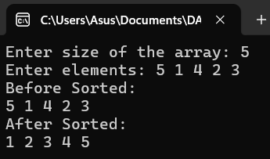

**8. Bubble Sort.**

#include<stdio.h>

void bubbleSort(int arr[],int n){

int i,j,temp;

for(i=0;i<n;i++){

for(j=0;j<n-1;j++){

if(arr[j]>arr[j+1]){

temp=arr[j];

arr[j]=arr[j+1];

arr[j+1]=temp;

}

}

}

}

void printArray(int arr[],int n){

int i;

for(i=0;i<n;i++){

printf("%d ",arr[i]);

}

printf("\n");

}

int main(){

int i,n;

printf("Enter size of the array: ");

scanf("%d",&n);

int arr[n];

printf("Enter elements: ");

for(i=0;i<n;i++){

scanf("%d",&arr[i]);

}

printf("Before Sorted:\n");

printArray(arr,n);

bubbleSort(arr,n);

printf("After Sorted:\n");

printArray(arr,n);

return 0;

}

**Output:**



**9. Matrix Multiplication.**

#include<stdio.h>

int main(){

int a[3][3],b[3][3],c[3][3];

int i,j,k;

printf("Enter first matrix: \n");

for(i=0;i<3;i++){

for(j=0;j<3;j++){

scanf("%d",&a[i][j]);

}

}

printf("Enter second matrix: \n");

for(i=0;i<3;i++){

for(j=0;j<3;j++){

scanf("%d",&b[i][j]);

}

}

for(i=0;i<3;i++){

for(j=0;j<3;j++){

c[i][j]=0;

for(k=0;k<3;k++){

c[i][j]+=a[i][k]*b[k][j];

}

}

}

printf("Multiplied matrix:\n");

for(i=0;i<3;i++){

for(j=0;j<3;j++){

printf("%d ",c[i][j]);

}

printf("\n");

}

return 0;

}

**Output:**

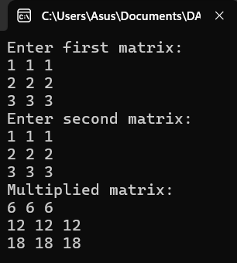

**10. String Palindrome.**

#include<stdio.h>

#include<string.h>

int main(){

char str[100],temp,ori[100];

printf("Enter a string: ");

scanf("%s",str);

strcpy(ori,str);

int l=strlen(str);

int s,e;

s=0;

e=l-1;

while(s<e){

temp=str[s];

str[s]=str[e];

str[e]=temp;

s++;

e--;

}

printf("%s\n",str);

if(strcmp(ori,str)==0){

printf("Palindrome");

}

else{

printf("Not Palindrome");

}

return 0;

}

**Output:**

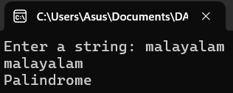

**11. Copy String.**

#include <stdio.h>

#include<string.h>

int main() {

char str[100], ori[100];

int i;

printf("Enter a string: ");

scanf("%s",str);

for(i=0;i<strlen(str);i++){

ori[i]=str[i];

}

printf("%s",ori);

return 0;

}

**Output:**

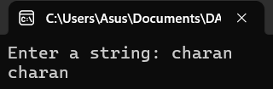

12. Binary Search.

#include<stdio.h>

int binarySearch(int arr[],int n,int target){

int low=0,high=n-1;

while(low<=high){

int mid=(low+high)/2;

if(arr[mid]==target){

return mid;

}

if(arr[mid]<target){

low=mid+1;

}

else{

high=mid-1;

}

}

return -1;

}

int main(){

int i,n,target;

printf("Enter size of the array: ");

scanf("%d",&n);

int arr[n];

printf("Enter elements: ");

for(i=0;i<n;i++){

scanf("%d",&arr[i]);

}

printf("Enter target: ");

scanf("%d",&target);

int result=binarySearch(arr,n,target);

if(result!=-1){

printf("Element found at index %d",result);

}

else{

printf("Element not found");

}

return 0;

}

**Output:**

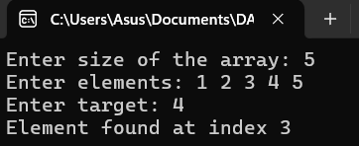

**13. Reverse String.**

#include<stdio.h>

#include<string.h>

int main(){

char str[100],temp,ori[100];

printf("Enter a string: ");

scanf("%s",str);

strcpy(ori,str);

int l=strlen(str);

int s,e;

s=0;

e=l-1;

while(s<e){

temp=str[s];

str[s]=str[e];

str[e]=temp;

s++;

e--;

}

printf("Reversed String: %s\n",str);

return 0;

}

**Output:**

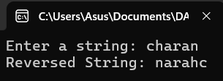

**14. String length.**

#include<stdio.h>

int main(){

char str[100];

int i,count=0;

printf("Enter a string: ");

scanf("%s",str);

for(i=0;str[i]!='\0';i++){

if(str[i]!='\n'){

count++;

}

}

printf("Length of the string is %d",count);

return 0;

}

**Output:**

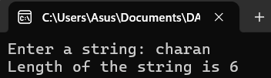

**15. Strassen’s Matrix.**

#include <stdio.h>

#include <stdlib.h>

#define MAX 4 // Matrix size 4x4

// Function to add matrices

void add(int A[MAX][MAX], int B[MAX][MAX], int C[MAX][MAX], int size) {

for (int i = 0; i < size; i++) {

for (int j = 0; j < size; j++) {

C[i][j] = A[i][j] + B[i][j];

}

}

}

// Function to subtract matrices

void subtract(int A[MAX][MAX], int B[MAX][MAX], int C[MAX][MAX], int size) {

for (int i = 0; i < size; i++) {

for (int j = 0; j < size; j++) {

C[i][j] = A[i][j] - B[i][j];

}

}

}

// Strassen's algorithm for matrix multiplication

void strassen(int A[MAX][MAX], int B[MAX][MAX], int C[MAX][MAX], int size) {

if (size == 1) {

C[0][0] = A[0][0] * B[0][0];

return;

}

int newSize = size / 2;

int A11[MAX][MAX], A12[MAX][MAX], A21[MAX][MAX], A22[MAX][MAX];

int B11[MAX][MAX], B12[MAX][MAX], B21[MAX][MAX], B22[MAX][MAX];

int C11[MAX][MAX], C12[MAX][MAX], C21[MAX][MAX], C22[MAX][MAX];

int M1[MAX][MAX], M2[MAX][MAX], M3[MAX][MAX], M4[MAX][MAX], M5[MAX][MAX], M6[MAX][MAX], M7[MAX][MAX];

int temp1[MAX][MAX], temp2[MAX][MAX];

// Divide the matrices into submatrices

for (int i = 0; i < newSize; i++) {

for (int j = 0; j < newSize; j++) {

A11[i][j] = A[i][j];

A12[i][j] = A[i][j + newSize];

A21[i][j] = A[i + newSize][j];

A22[i][j] = A[i + newSize][j + newSize];

B11[i][j] = B[i][j];

B12[i][j] = B[i][j + newSize];

B21[i][j] = B[i + newSize][j];

B22[i][j] = B[i + newSize][j + newSize];

}

}

// Calculate M1 to M7

add(A11, A22, temp1, newSize);

add(B11, B22, temp2, newSize);

strassen(temp1, temp2, M1, newSize);

add(A21, A22, temp1, newSize);

strassen(temp1, B11, M2, newSize);

subtract(B12, B22, temp2, newSize);

strassen(A11, temp2, M3, newSize);

subtract(B21, B11, temp2, newSize);

strassen(A22, temp2, M4, newSize);

add(A11, A12, temp1, newSize);

strassen(temp1, B22, M5, newSize);

subtract(A21, A11, temp1, newSize);

add(B11, B12, temp2, newSize);

strassen(temp1, temp2, M6, newSize);

subtract(A12, A22, temp1, newSize);

add(B21, B22, temp2, newSize);

strassen(temp1, temp2, M7, newSize);

// Calculate C11, C12, C21, C22

add(M1, M4, temp1, newSize);

subtract(temp1, M5, temp2, newSize);

add(temp2, M7, C11, newSize);

add(M3, M5, C12, newSize);

add(M2, M4, C21, newSize);

add(M1, M3, temp1, newSize);

subtract(temp1, M2, temp2, newSize);

add(temp2, M6, C22, newSize);

// Combine C11, C12, C21, C22 into C

for (int i = 0; i < newSize; i++) {

for (int j = 0; j < newSize; j++) {

C[i][j] = C11[i][j];

C[i][j + newSize] = C12[i][j];

C[i + newSize][j] = C21[i][j];

C[i + newSize][j + newSize] = C22[i][j];

}

}

}

// Function to take matrix input

void inputMatrix(int A[MAX][MAX], int size) {

printf("Enter elements of the matrix:\n");

for (int i = 0; i < size; i++) {

for (int j = 0; j < size; j++) {

printf("Element A[%d][%d]: ", i, j);

scanf("%d", &A[i][j]);

}

}

}

// Function to display matrix

void displayMatrix(int A[MAX][MAX], int size) {

printf("Result matrix:\n");

for (int i = 0; i < size; i++) {

for (int j = 0; j < size; j++) {

printf("%d ", A[i][j]);

}

printf("\n");

}

}

int main() {

int size = MAX; // Matrix size is 4x4

int A[MAX][MAX], B[MAX][MAX], C[MAX][MAX];

// Input matrices A and B

inputMatrix(A, size);

inputMatrix(B, size);

// Perform Strassen's matrix multiplication

strassen(A, B, C, size);

// Display the result

displayMatrix(C, size);

return 0;

}

**Output:**

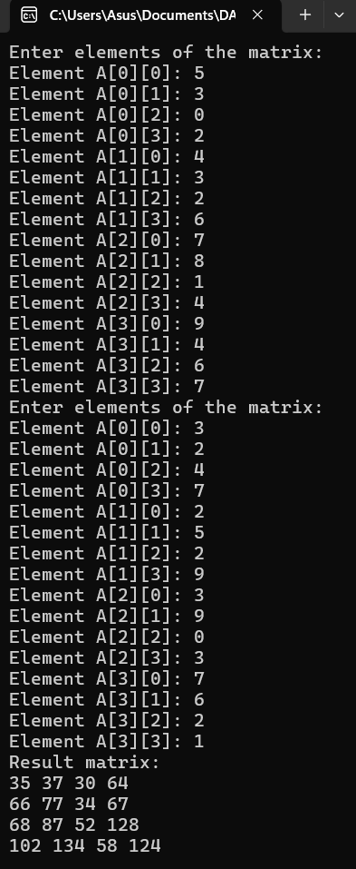

**16. Merge Sort.**

#include <stdio.h>

// Function to merge two subarrays

void merge(int arr[], int left, int mid, int right) {

int n1 = mid - left + 1;

int n2 = right - mid;

// Create temporary arrays

int L[n1], R[n2];

// Copy data to temporary arrays L[] and R[]

for (int i = 0; i < n1; i++) {

L[i] = arr[left + i];

}

for (int j = 0; j < n2; j++) {

R[j] = arr[mid + 1 + j];

}

// Merge the temporary arrays back into arr[left..right]

int i = 0, j = 0, k = left;

while (i < n1 && j < n2) {

if (L[i] <= R[j]) {

arr[k] = L[i];

i++;

} else {

arr[k] = R[j];

j++;

}

k++;

}

// Copy the remaining elements of L[], if any

while (i < n1) {

arr[k] = L[i];

i++;

k++;

}

// Copy the remaining elements of R[], if any

while (j < n2) {

arr[k] = R[j];

j++;

k++;

}

}

// Function to implement merge sort

void mergeSort(int arr[], int left, int right) {

if (left < right) {

int mid = left + (right - left) / 2;

// Recursively sort the first and second halves

mergeSort(arr, left, mid);

mergeSort(arr, mid + 1, right);

// Merge the sorted halves

merge(arr, left, mid, right);

}

}

// Function to print the array

void printArray(int arr[], int size) {

for (int i = 0; i < size; i++) {

printf("%d ", arr[i]);

}

printf("\n");

}

// Main function to test the merge sort

int main() {

int arrSize;

// Get user input for array size

printf("Enter the number of elements: ");

scanf("%d", &arrSize);

int arr[arrSize];

// Get user input for array elements

printf("Enter the elements of the array:\n");

for (int i = 0; i < arrSize; i++) {

scanf("%d", &arr[i]);

}

printf("Original array: \n");

printArray(arr, arrSize);

mergeSort(arr, 0, arrSize - 1);

printf("Sorted array: \n");

printArray(arr, arrSize);

return 0;

}

**Output:**



**17. Min and Max elements in array.**

#include <stdio.h>

void findMinMax(int arr[], int n) {

int min = arr[0];

int max = arr[0];

for (int i = 1; i < n; i++) {

if (arr[i] < min) {

min = arr[i];

}

if (arr[i] > max) {

max = arr[i];

}

}

printf("Minimum element: %d\n", min);

printf("Maximum element: %d\n", max);

}

int main() {

int n;

// Input the number of elements

printf("Enter the number of elements in the array: ");

scanf("%d", &n);

int arr[n];

// Input the array elements

printf("Enter the elements of the array: \n");

for (int i = 0; i < n; i++) {

scanf("%d", &arr[i]);

}

// Call the function to find the min and max

findMinMax(arr, n);

return 0;

}

**Output:**

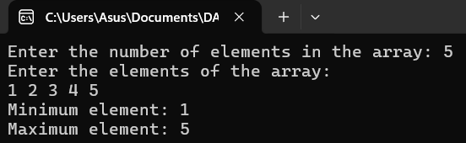

**18. Prime numbers between 1 and 100.**

#include <stdio.h>

#include <stdbool.h>

// Function to check if a number is prime

bool isPrime(int num) {

if (num <= 1) {

return false; // 1 and numbers less than 1 are not prime

}

for (int i = 2; i * i <= num; i++) {

if (num % i == 0) {

return false; // Number is divisible by i, so it's not prime

}

}

return true; // If no divisors were found, the number is prime

}

int main() {

printf("Prime numbers between 1 and 100 are:\n");

for (int i = 1; i <= 100; i++) {

if (isPrime(i)) {

printf("%d ", i);

}

}

return 0;

}

**Output:**

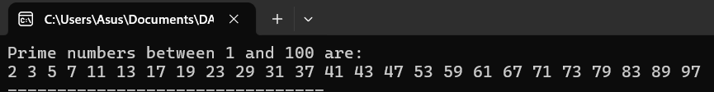

**19. Knapsack using Greedy method.**

#include <stdio.h>

#include <stdlib.h>

// Structure for an item

struct Item {

int value;

int weight;

float ratio; // Value-to-weight ratio

};

// Comparison function for sorting items based on value-to-weight ratio

int compare(const void *a, const void *b) {

float ratio1 = ((struct Item*)a)->ratio;

float ratio2 = ((struct Item*)b)->ratio;

return (ratio2 - ratio1 > 0) - (ratio2 - ratio1 < 0);

}

// Function to solve the Fractional Knapsack problem using Greedy approach

float knapsack(struct Item items[], int n, int capacity) {

// Sort items by value-to-weight ratio in descending order

qsort(items, n, sizeof(struct Item), compare);

float totalValue = 0.0;

int remainingCapacity = capacity;

for (int i = 0; i < n; i++) {

if (items[i].weight <= remainingCapacity) {

// Take the whole item

remainingCapacity -= items[i].weight;

totalValue += items[i].value;

} else {

// Take the fraction of the item that fits

totalValue += items[i].value * ((float)remainingCapacity / items[i].weight);

break;

}

}

return totalValue;

}

int main() {

int n, capacity;

// Input number of items and knapsack capacity

printf("Enter the number of items: ");

scanf("%d", &n);

printf("Enter the capacity of the knapsack: ");

scanf("%d", &capacity);

struct Item items[n];

// Input value, weight and calculate value-to-weight ratio for each item

printf("Enter the value and weight for each item:\n");

for (int i = 0; i < n; i++) {

scanf("%d %d", &items[i].value, &items[i].weight);

items[i].ratio = (float)items[i].value / items[i].weight;

}

// Calculate the maximum value that can be obtained

float maxValue = knapsack(items, n, capacity);

// Output the result

printf("Maximum value that can be obtained: %.2f\n", maxValue);

return 0;

}

**Output:**

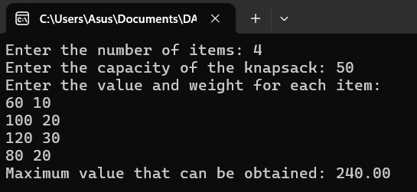

**20. MST using Greedy techniques.**

#include <stdio.h>

#include <limits.h>

#include <stdbool.h>

#define V 100 // Maximum number of vertices

// Function to find the vertex with the minimum key value

int minKey(int key[], bool mstSet[], int vertices) {

int min = INT_MAX, min_index;

for (int v = 0; v < vertices; v++) {

if (mstSet[v] == false && key[v] < min) {

min = key[v];

min_index = v;

}

}

return min_index;

}

// Function to print the constructed MST and calculate the total weight

void printMST(int parent[], int graph[V][V], int vertices) {

int totalWeight = 0;

printf("Edge \tWeight\n");

for (int i = 1; i < vertices; i++) {

printf("%d - %d \t%d\n", parent[i], i, graph[i][parent[i]]);

totalWeight += graph[i][parent[i]]; // Sum the weights

}

printf("Total Minimum Weight of MST: %d\n", totalWeight);

}

// Function to construct and print the MST using Prim's algorithm

void primMST(int graph[V][V], int vertices) {

int parent[V]; // Array to store the constructed MST

int key[V]; // Key values used to pick the minimum weight edge

bool mstSet[V]; // To represent the set of vertices included in MST

// Initialize all keys as INFINITE

for (int i = 0; i < vertices; i++) {

key[i] = INT_MAX;

mstSet[i] = false;

}

// Include the first vertex in MST

key[0] = 0;

parent[0] = -1; // First node is always the root of the MST

for (int count = 0; count < vertices - 1; count++) {

int u = minKey(key, mstSet, vertices);

mstSet[u] = true;

for (int v = 0; v < vertices; v++) {

if (graph[u][v] && mstSet[v] == false && graph[u][v] < key[v]) {

parent[v] = u;

key[v] = graph[u][v];

}

}

}

printMST(parent, graph, vertices);

}

int main() {

int vertices;

printf("Enter the number of vertices: ");

scanf("%d", &vertices);

int graph[V][V];

printf("Enter the adjacency matrix (use 0 for no connection):\n");

for (int i = 0; i < vertices; i++) {

for (int j = 0; j < vertices; j++) {

scanf("%d", &graph[i][j]);

}

}

primMST(graph, vertices);

return 0;

}

**Output:**

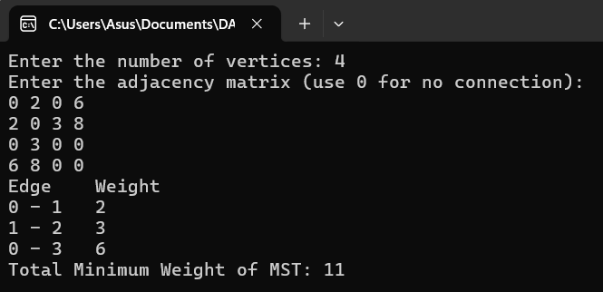

**21. OBST using Dynamic Programming.**

#include <stdio.h>

#include <limits.h>

// Function to calculate the sum of frequencies from i to j

int sum(int freq[], int i, int j) {

int s = 0;

for (int k = i; k <= j; k++) {

s += freq[k];

}

return s;

}

// Function to build the OBST using dynamic programming

int optimalSearchTree(int keys[], int freq[], int n) {

int cost[n][n]; // cost[i][j] stores the minimum cost of OBST for keys[i..j]

// Initialize the cost of single keys (single nodes)

for (int i = 0; i < n; i++) {

cost[i][i] = freq[i];

}

// Build the table for subtrees of increasing size

for (int length = 2; length <= n; length++) {

for (int i = 0; i <= n - length; i++) {

int j = i + length - 1;

cost[i][j] = INT_MAX;

// Try making each key in keys[i..j] as the root

for (int r = i; r <= j; r++) {

int c = ((r > i) ? cost[i][r - 1] : 0) +

((r < j) ? cost[r + 1][j] : 0) +

sum(freq, i, j);

if (c < cost[i][j]) {

cost[i][j] = c;

}

}

}

}

return cost[0][n - 1]; // Minimum cost of OBST for keys[0..n-1]

}

int main() {

int n;

printf("Enter the number of keys: ");

scanf("%d", &n);

int keys[n], freq[n];

printf("Enter the keys:\n");

for (int i = 0; i < n; i++) {

scanf("%d", &keys[i]);

}

printf("Enter the frequencies:\n");

for (int i = 0; i < n; i++) {

scanf("%d", &freq[i]);

}

int minCost = optimalSearchTree(keys, freq, n);

printf("The minimum cost of the Optimal Binary Search Tree is: %d\n", minCost);

return 0;

}

**Output:**

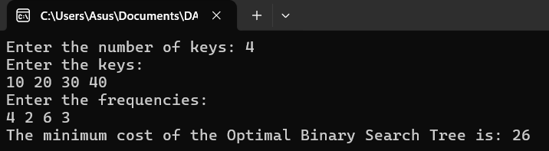

**22. Binomial Coefficient.**

#include <stdio.h>

// Function to calculate Binomial Coefficient using dynamic programming

int binomialCoeff(int n, int k) {

int C[n+1][k+1];

// Calculate value of Binomial Coefficient in bottom-up manner

for (int i = 0; i <= n; i++) {

for (int j = 0; j <= (i < k ? i : k); j++) {

// Base Case: C(i, 0) = 1 and C(i, i) = 1

if (j == 0 || j == i) {

C[i][j] = 1;

} else {

// Recursive Case: C(i, j) = C(i-1, j-1) + C(i-1, j)

C[i][j] = C[i-1][j-1] + C[i-1][j];

}

}

}

return C[n][k]; // Return the binomial coefficient C(n, k)

}

int main() {

int n, k;

// Input values for n and k

printf("Enter values of n and k: ");

scanf("%d %d", &n, &k);

// Output the binomial coefficient

printf("Binomial Coefficient C(%d, %d) = %d\n", n, k, binomialCoeff(n, k));

return 0;

}

**Output:**

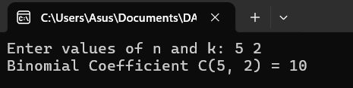

**23. Reverse a number.**

#include <stdio.h>

int main() {

int num, reversed = 0, remainder;

printf("Enter a number: ");

scanf("%d", &num);

while (num != 0) {

remainder = num % 10;

reversed = reversed * 10 + remainder;

num = num / 10;

}

printf("Reversed number: %d\n", reversed);

return 0;

}

**Output:**

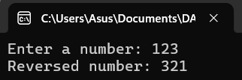

**24. Perfect number.**

#include <stdio.h>

int main() {

int num, sum = 0;

printf("Enter a number: ");

scanf("%d", &num);

for (int i = 1; i <= num / 2; i++) {

if (num % i == 0) {

sum += i;

}

}

if (sum == num) {

printf("%d is a Perfect Number.\n", num);

} else {

printf("%d is not a Perfect Number.\n", num);

}

return 0;

}

**Output:**

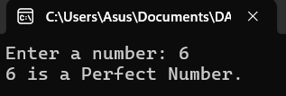

**25. TSP using Dynamic Programming.**

#include <stdio.h>

#define MAX 16

#define INF 9999999 // Define a large number to represent infinity

int dp[1 << MAX][MAX]; // DP table to store the minimum cost

int dist[MAX][MAX]; // Matrix to store distances between cities

// Function to solve the Traveling Salesman Problem using Dynamic Programming and Bitmasking

int tsp(int mask, int pos, int n) {

if (mask == (1 << n) - 1) { // All cities have been visited

return dist[pos][0]; // Return to the starting city

}

if (dp[mask][pos] != -1) // If the result is already calculated, return it

return dp[mask][pos];

int ans = INF;

for (int city = 0; city < n; city++) {

if ((mask & (1 << city)) == 0) { // If the city hasn't been visited

int newAns = dist[pos][city] + tsp(mask | (1 << city), city, n);

ans = (ans < newAns) ? ans : newAns; // Choose the minimum cost

}

}

return dp[mask][pos] = ans; // Store the result in DP table

}

int main() {

int n;

printf("Enter the number of cities: ");

scanf("%d", &n);

if (n > MAX) {

printf("The maximum number of cities supported is %d.\n", MAX);

return -1;

}

printf("Enter the distance matrix:\n");

for (int i = 0; i < n; i++) {

for (int j = 0; j < n; j++) {

scanf("%d", &dist[i][j]);

}

}

// Initialize DP table with -1 (meaning uncalculated)

for (int i = 0; i < (1 << n); i++) {

for (int j = 0; j < n; j++) {

dp[i][j] = -1;

}

}

// Calculate the result starting from city 0, with only city 0 visited (mask = 1)

int result = tsp(1, 0, n);

printf("The minimum cost of the tour is: %d\n", result);

return 0;

}

**Output:**

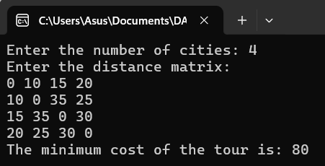

**26. Print the pattern.**

#include <stdio.h>

int main() {

int i, j, n;

printf("Enter the number of rows: ");

scanf("%d", &n);

for (i = 1; i <= n; i++) {

for (j = 1; j <= i; j++) {

printf("* ");

}

printf("\n");

}

return 0;

}

**Output:**

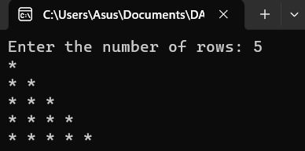

**27. Floyd’s algorithm.**

#include <stdio.h>

#define INF 9999999

#define MAX 10

void floydWarshall(int graph[MAX][MAX], int n) {

int dist[MAX][MAX], i, j, k;

for (i = 0; i < n; i++) {

for (j = 0; j < n; j++) {

if (i == j) dist[i][j] = 0;

else if (graph[i][j] == 0) dist[i][j] = INF;

else dist[i][j] = graph[i][j];

}

}

for (k = 0; k < n; k++) {

for (i = 0; i < n; i++) {

for (j = 0; j < n; j++) {

if (dist[i][j] > dist[i][k] + dist[k][j]) dist[i][j] = dist[i][k] + dist[k][j];

}

}

}

printf("The shortest distances between every pair of vertices are:\n");

for (i = 0; i < n; i++) {

for (j = 0; j < n; j++) {

if (dist[i][j] == INF) printf("INF ");

else printf("%d ", dist[i][j]);

}

printf("\n");

}

}

int main() {

int n, i, j;

printf("Enter the number of vertices: ");

scanf("%d", &n);

int graph[MAX][MAX];

printf("Enter the adjacency matrix (use 0 for no edge and a positive integer for edge weights):\n");

for (i = 0; i < n; i++) {

for (j = 0; j < n; j++) {

scanf("%d", &graph[i][j]);

}

}

floydWarshall(graph, n);

return 0;

}

**Output:**

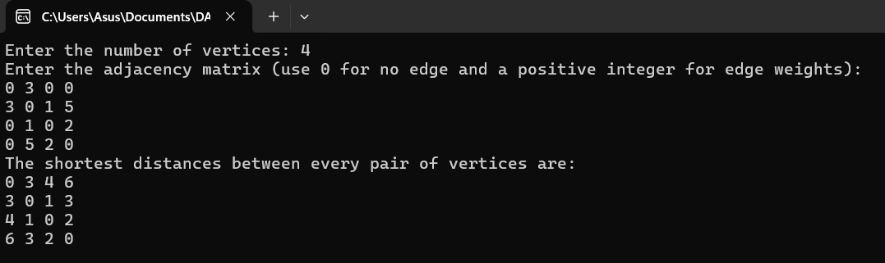

**28. Pascal’s Triangle.**

#include <stdio.h>

int main() {

int n, i, j, val, space;

printf("Enter the number of rows: ");

scanf("%d", &n);

for (i = 0; i < n; i++) {

for (space = 0; space < n - i - 1; space++) {

printf(" ");

}

val = 1;

for (j = 0; j <= i; j++) {

printf("%4d", val);

val = val * (i - j) / (j + 1);

}

printf("\n");

}

return 0;

}

**Output:**

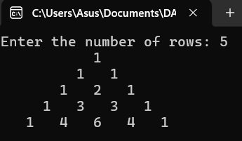

**29. Sum of digits.**

#include <stdio.h>

int main() {

int num, sum = 0;

printf("Enter a number: ");

scanf("%d", &num);

while (num != 0) {

sum += num % 10;

num /= 10;

}

printf("Sum of digits: %d\n", sum);

return 0;

}

**Output:**

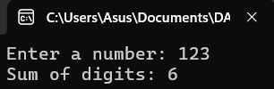

**30. Inserting element in an array.**

#include <stdio.h>

int main() {

int arr[100], n, pos, elem, i;

printf("Enter the number of elements: ");

scanf("%d", &n);

printf("Enter the elements:\n");

for (i = 0; i < n; i++) {

scanf("%d", &arr[i]);

}

printf("Enter the position to insert (1 to %d): ", n + 1);

scanf("%d", &pos);

printf("Enter the element to insert: ");

scanf("%d", &elem);

for (i = n; i >= pos - 1; i--) {

arr[i + 1] = arr[i];

}

arr[pos - 1] = elem;

n++;

printf("Array after insertion:\n");

for (i = 0; i < n; i++) {

printf("%d ", arr[i]);

}

return 0;

}  
**Output:**

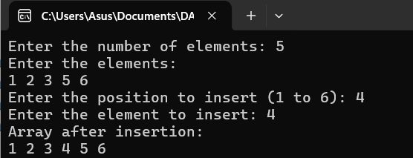

**31. Sum of subsets.**

#include <stdio.h>

int total = 0;

void subsetSum(int set[], int subset[], int n, int subsetSize, int sum, int targetSum, int index) {

if (sum == targetSum) {

for (int i = 0; i < subsetSize; i++) {

printf("%d ", subset[i]);

}

printf("\n");

return;

}

for (int i = index; i < n; i++) {

if (sum + set[i] <= targetSum) {

subset[subsetSize] = set[i];

subsetSum(set, subset, n, subsetSize + 1, sum + set[i], targetSum, i + 1);

}

}

}

int main() {

int n, targetSum;

printf("Enter the number of elements: ");

scanf("%d", &n);

int set[n], subset[n];

printf("Enter the elements of the set:\n");

for (int i = 0; i < n; i++) {

scanf("%d", &set[i]);

}

printf("Enter the target sum: ");

scanf("%d", &targetSum);

printf("Subsets with the given sum:\n");

subsetSum(set, subset, n, 0, 0, targetSum, 0);

return 0;

}

**Output:**

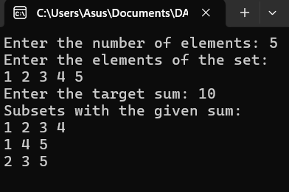

**32. Graph coloring.**

#include <stdio.h>

#define MAX 10

int graph[MAX][MAX], colors[MAX], n;

int isSafe(int node, int color) {

for (int i = 0; i < n; i++) {

if (graph[node][i] && colors[i] == color) {

return 0;

}

}

return 1;

}

int graphColoring(int node, int m) {

if (node == n) {

return 1;

}

for (int color = 1; color <= m; color++) {

if (isSafe(node, color)) {

colors[node] = color;

if (graphColoring(node + 1, m)) {

return 1;

}

colors[node] = 0;

}

}

return 0;

}

int main() {

int m;

printf("Enter the number of vertices: ");

scanf("%d", &n);

printf("Enter the adjacency matrix:\n");

for (int i = 0; i < n; i++) {

for (int j = 0; j < n; j++) {

scanf("%d", &graph[i][j]);

}

}

printf("Enter the number of colors: ");

scanf("%d", &m);

if (graphColoring(0, m)) {

printf("Solution exists with the following coloring:\n");

for (int i = 0; i < n; i++) {

printf("Vertex %d -> Color %d\n", i, colors[i]);

}

} else {

printf("No solution exists with %d colors.\n", m);

}

return 0;

}

**Output:**

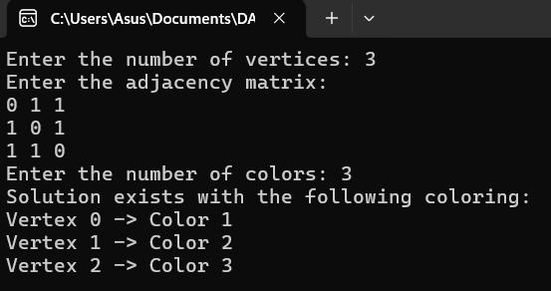

**33. Container loader problem.**

#include <stdio.h>

int main() {

int numItems, i;

float capacity, totalWeight = 0.0, itemWeight;

// Get container capacity from user

printf("Enter the container capacity (in kg): ");

scanf("%f", &capacity);

// Get the number of items to load

printf("Enter the number of items: ");

scanf("%d", &numItems);

float itemWeights[numItems];

// Get the weights of all items from user

for(i = 0; i < numItems; i++) {

printf("Enter the weight of item %d (in kg): ", i + 1);

scanf("%f", &itemWeights[i]);

}

// Try to load items into the container

for(i = 0; i < numItems; i++) {

itemWeight = itemWeights[i];

// Check if adding the item exceeds the container capacity

if(totalWeight + itemWeight > capacity) {

printf("Container is full, cannot load more items.\n");

break;

} else {

totalWeight += itemWeight;

printf("Item %d (weight: %.2f kg) loaded successfully. Total weight: %.2f kg\n", i + 1, itemWeight, totalWeight);

}

}

if(totalWeight == capacity) {

printf("Container is now full.\n");

} else {

printf("Total weight loaded into the container: %.2f kg\n", totalWeight);

}

return 0;

}

**Output:**

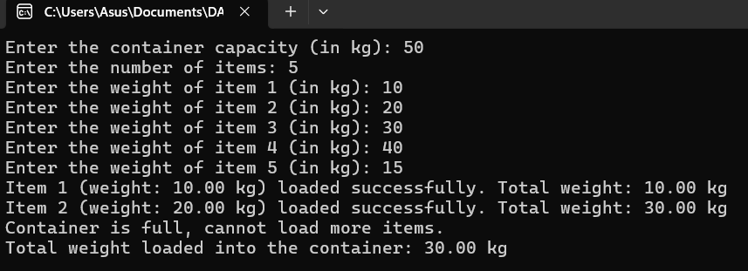

**34. Factors of a given number.**

#include <stdio.h>

int main() {

int n, i;

// Get the value of n from the user

printf("Enter a number: ");

scanf("%d", &n);

printf("Factors of %d are: ", n);

// Loop from 1 to n to find the factors

for(i = 1; i <= n; i++) {

if(n % i == 0) { // Check if i is a factor of n

printf("%d ", i);

}

}

printf("\n");

return 0;

}

**Output:**

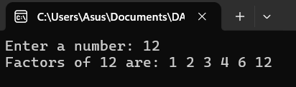

**35. Assignment problem.**

#include <stdio.h>

#include <limits.h>

#define N 4 // Size of the matrix (number of tasks and workers)

int cost[N][N];

int finalAssignment[N];

int minCost = INT_MAX;

void printSolution(int assignment[], int costMatrix[N][N]) {

printf("Optimal Assignment:\n");

for (int i = 0; i < N; i++) {

printf("Task %d -> Worker %d\n", i + 1, assignment[i] + 1);

}

printf("Minimum Cost: %d\n", minCost);

}

int calculateCost(int assignment[], int costMatrix[N][N]) {

int totalCost = 0;

for (int i = 0; i < N; i++) {

totalCost += costMatrix[i][assignment[i]];

}

return totalCost;

}

void boundAndBranch(int costMatrix[N][N], int assignment[], int n, int level, int currentCost, int visited[]) {

if (level == n) {

// Base case: all tasks assigned

if (currentCost < minCost) {

minCost = currentCost;

for (int i = 0; i < n; i++) {

finalAssignment[i] = assignment[i];

}

}

return;

}

// Loop through all workers to try assigning tasks

for (int i = 0; i < n; i++) {

if (!visited[i]) {

visited[i] = 1;

assignment[level] = i;

int newCost = currentCost + costMatrix[level][i];

if (newCost < minCost) {

boundAndBranch(costMatrix, assignment, n, level + 1, newCost, visited);

}

visited[i] = 0; // Backtrack

}

}

}

int main() {

int assignment[N] = {-1, -1, -1, -1}; // Holds the final assignment

int visited[N] = {0, 0, 0, 0}; // Keeps track of assigned workers

// Input the entire cost matrix at once

printf("Enter the cost matrix for the assignment problem (size %dx%d), space-separated values:\n", N, N);

for (int i = 0; i < N; i++) {

for (int j = 0; j < N; j++) {

scanf("%d", &cost[i][j]);

}

}

boundAndBranch(cost, assignment, N, 0, 0, visited);

printSolution(finalAssignment, cost);

return 0;

}

**Output:**

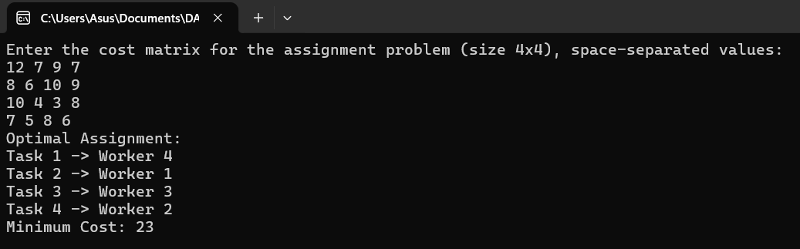

**36. Linear search.**

#include <stdio.h>

int linearSearch(int arr[], int size, int target) {

for (int i = 0; i < size; i++) {

if (arr[i] == target) {

return i; // Return index if element is found

}

}

return -1; // Return -1 if element is not found

}

int main() {

int size, target;

// Input array size

printf("Enter the number of elements in the array: ");

scanf("%d", &size);

int arr[size]; // Declare the array with the given size

// Input array elements

printf("Enter the elements of the array: ");

for (int i = 0; i < size; i++) {

scanf("%d", &arr[i]);

}

// Input the target element to search

printf("Enter the element to search for: ");

scanf("%d", &target);

int result = linearSearch(arr, size, target);

if (result != -1) {

printf("Element %d found at index %d.\n", target, result);

} else {

printf("Element %d not found in the array.\n", target);

}

return 0;

}

**Output:**

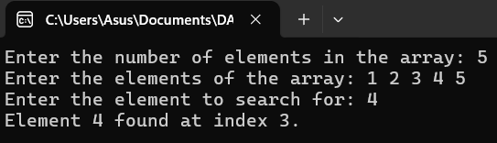

**37. Hamiltonian circuit.**

#include <stdio.h>

#include <stdbool.h>

#define MAX_NODES 100

void generateCompleteGraph(int graph[MAX_NODES][MAX_NODES], int nodes) {

for (int i = 0; i < nodes; i++)

for (int j = 0; j < nodes; j++)

graph[i][j] = (i != j);

}

bool isSafe(int v, int graph[MAX_NODES][MAX_NODES], int path[], int pos) {

if (!graph[path[pos - 1]][v]) return false;

for (int i = 0; i < pos; i++)

if (path[i] == v) return false;

return true;

}

bool hamiltonianCycleUtil(int graph[MAX_NODES][MAX_NODES], int path[], int pos, int nodes) {

if (pos == nodes) return graph[path[pos - 1]][path[0]];

for (int v = 1; v < nodes; v++) {

if (isSafe(v, graph, path, pos)) {

path[pos] = v;

if (hamiltonianCycleUtil(graph, path, pos + 1, nodes)) return true;

path[pos] = -1;

}

}

return false;

}

void findHamiltonianCycle(int graph[MAX_NODES][MAX_NODES], int nodes) {

int path[MAX_NODES];

for (int i = 0; i < nodes; i++) path[i] = -1;

path[0] = 0;

if (hamiltonianCycleUtil(graph, path, 1, nodes)) {

printf("Hamiltonian Cycle found: ");

for (int i = 0; i < nodes; i++) printf("%d ", path[i]);

printf("%d\n", path[0]);

} else {

printf("No Hamiltonian Cycle found.\n");

}

}

int main() {

int nodes, graph[MAX_NODES][MAX_NODES];

printf("Enter number of nodes (max %d): ", MAX_NODES);

scanf("%d", &nodes);

if (nodes < 3 || nodes > MAX_NODES) {

printf("Invalid number of nodes.\n");

return 1;

}

generateCompleteGraph(graph, nodes);

findHamiltonianCycle(graph, nodes);

return 0;

}

**Output:**

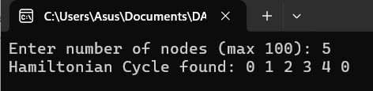

**38. N queen’s problem.**

#include <stdio.h>

#include <stdlib.h> // For abs()

// Function to print the board with queens placed on it

void printSolution(int board[], int N) {

printf("Solution:\n");

for (int i = 0; i < N; i++) {

for (int j = 0; j < N; j++) {

if (board[i] == j) {

printf(" Q "); // Queen is placed at [i, j]

} else {

printf(" * "); // Empty space

}

}

printf("\n");

}

printf("\n");

}

// Function to check if it's safe to place a queen at [row, col]

int isSafe(int board[], int row, int col, int N) {

for (int i = 0; i < row; i++) {

if (board[i] == col || abs(board[i] - col) == abs(i - row)) {

return 0; // Conflict with another queen

}

}

return 1; // No conflict

}

// Backtracking function to solve the N-Queens problem

int solveNQueens(int board[], int row, int N) {

if (row == N) {

// All queens are placed successfully, print the solution

printSolution(board, N);

return 1; // Return true after finding the first solution

}

for (int col = 0; col < N; col++) {

if (isSafe(board, row, col, N)) {

board[row] = col; // Place queen at [row, col]

if (solveNQueens(board, row + 1, N)) {

return 1; // Stop after finding the first solution

}

}

}

return 0; // No solution found

}

int main() {

int N;

// Input the number of queens (size of the board)

printf("Enter the number of queens: ");

scanf("%d", &N);

// Initialize the board

int board[N];

for (int i = 0; i < N; i++) {

board[i] = -1; // No queens placed initially

}

// Solve the N-Queens problem

if (!solveNQueens(board, 0, N)) {

printf("No solution exists for %d queens.\n", N);

}

return 0;

}

**Output:**

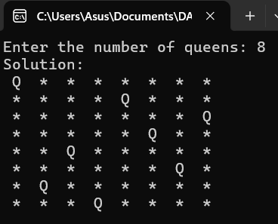

**39. Approximation algorithm.**

#include <stdio.h>

#include <math.h>

#define MAX_CITIES 10

#define INF 99999

// Function to calculate the distance between two cities (Euclidean distance)

double distance(int city1[], int city2[]) {

return sqrt(pow(city1[0] - city2[0], 2) + pow(city1[1] - city2[1], 2));

}

// Nearest Neighbor Approximation Algorithm for TSP

double nearestNeighbor(int cities[][2], int n) {

int visited[n];

int path[n];

double totalDistance = 0.0;

// Initialize visited array

for (int i = 0; i < n; i++) {

visited[i] = 0; // No cities are visited initially

}

visited[0] = 1; // Start at the first city

path[0] = 0; // First city in the path

int currentCity = 0;

// Iterate through all cities

for (int i = 1; i < n; i++) {

double minDist = INF;

int nextCity = -1;

// Find the nearest unvisited city

for (int j = 0; j < n; j++) {

if (!visited[j]) {

double dist = distance(cities[currentCity], cities[j]);

if (dist < minDist) {

minDist = dist;

nextCity = j;

}

}

}

// Mark the next city as visited and add it to the path

visited[nextCity] = 1;

path[i] = nextCity;

totalDistance += minDist;

currentCity = nextCity;

}

// Add the distance to return to the start city

totalDistance += distance(cities[currentCity], cities[0]);

// Print the path

printf("Path: ");

for (int i = 0; i < n; i++) {

printf("%d ", path[i]);

}

printf("\n");

return totalDistance;

}

int main() {

int n;

// Input the number of cities

printf("Enter the number of cities: ");

scanf("%d", &n);

// Input the coordinates of the cities

int cities[n][2];

printf("Enter the coordinates of the cities (x y):\n");

for (int i = 0; i < n; i++) {

scanf("%d %d", &cities[i][0], &cities[i][1]);

}

// Call the nearest neighbor algorithm

double totalCost = nearestNeighbor(cities, n);

printf("Total travel distance: %.2f\n", totalCost);

return 0;

}

**Output:**

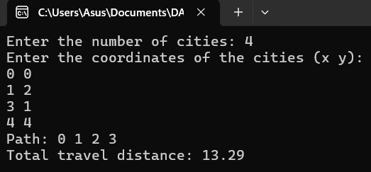

**40. Min and max in array.**

#include <stdio.h>

void findMinMax(int arr[], int n) {

int min = arr[0];

int max = arr[0];

for (int i = 1; i < n; i++) {

if (arr[i] < min) {

min = arr[i];

}

if (arr[i] > max) {

max = arr[i];

}

}

printf("Minimum element: %d\n", min);

printf("Maximum element: %d\n", max);

}

int main() {

int n;

// Input the number of elements

printf("Enter the number of elements in the array: ");

scanf("%d", &n);

int arr[n];

// Input the array elements

printf("Enter the elements of the array: \n");

for (int i = 0; i < n; i++) {

scanf("%d", &arr[i]);

}

// Call the function to find the min and max

findMinMax(arr, n);

return 0;

}

**Output:**

